NAME: _______________________________________________

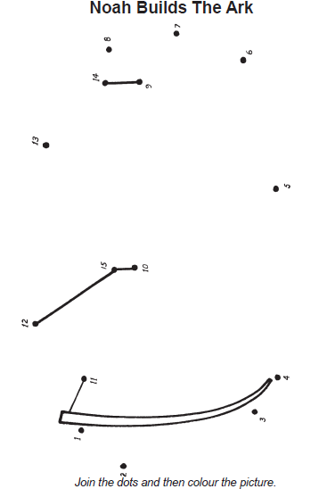

(ages 5-6)

NAME: _______________________________________________

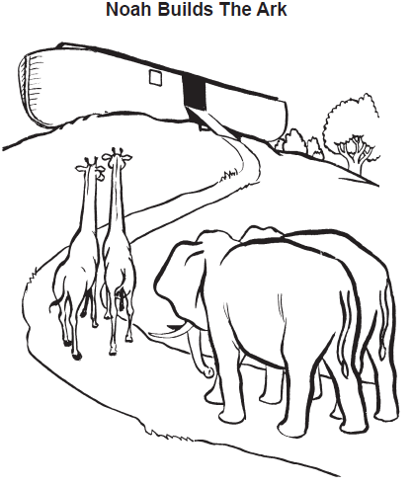

(ages 5-6)

